The Five Parts of a Map

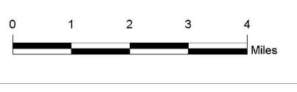
1. Scale: Scale is used to show that a certain distance on the map represents the actual distance on the earth’s surface. On a map, scale is represented using words (for example, one inch = 400 miles) or using a graphic (a line graph).

2. Title: What the map is about. The title is generally the biggest, darkest, most noticeable text on your map.

3. Legend or Key: Used for defining and understanding the symbols found on the map. It is usually in one of the corners of the map and is often enclosed by a box. It explains the meaning of the different sizes, shapes, and colors used in the map.
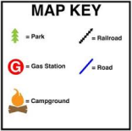

4. Symbols: The items on the map which stand for or represent real things on the earth’s surface. Symbols vary according to 2 categories: color and shape. For example: a star is often used to represent the capital city or yellow to represent a desert.

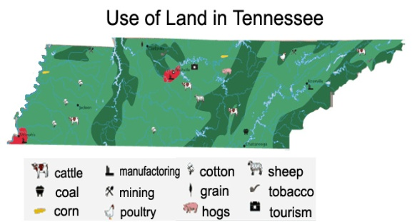

5. Compass: The compass shows which way is up on the map. Nearly all maps are printed so that north is towards the top of the page. This is shown by a compass rose using N, S, E, and W.

